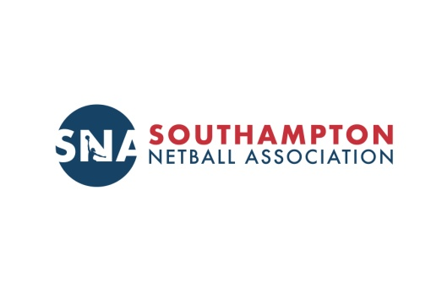
Volume 1, Issue 1 August 2017

INSIDE THIS ISSUE
2 | Welcome and Meet the Committee
3 | League Representatives
4 | Affiliation and Forms
5 | SNA Codes of Conduct
5 | Bank Details
5 | Courses
6 | Umpiring
7 | Club News

WELCOME ALL TO YOUR NEWSLETTER
The committee would like to welcome you to the first SNA newsletter.
Meet your committee
Chair

Mandy Gerrard
Vice Chair __ Vicky Ordish
Honorary Secretary Honorary Treasurer League and Tournament Administrator
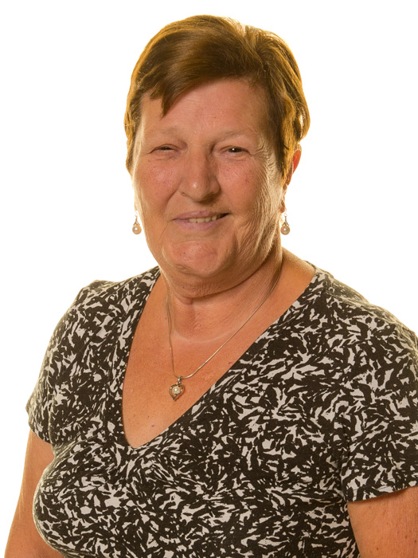
Val Banks Jackie Gibbings Chris Granger

Umpire Development Administrator Assistant League Administrator/ Publicity Officer / League Rep

Peter Bennett Christine Backshell Mo Aldridge
Coaching and Development Officer/ League Rep __ Carey Mc Cormick

League Representatives

Sarah Lambeth Kathi Coffin Amy MacIntosh
Forms
All League entry forms are now on the SNA Website
Winter League
Start Date: 23rd September
Closing Date for Entry 25th August
Entry Fee: £100 for current teams £120 for new teams
Margaret Whittaker League
Start Date 6th November
Closing Date for Entry 16th October
Entry Fee: £80 for current teams and £90 for new teams
Freddie Cook Sunlit League
Start Date 12th and/or 14th March
Closing Date for Entry 2nd February
Entry Fee: £110 for current teams and £120 for new teams
All teams to pay one annual affiliation fee £10 per team and £15 per team if affiliated outside Southampton
Indoor Tournament
Dates: 9th December, 13th, 20th, and 27th January,
Closing Date for entry 25th August
Entry Fee £60
Updated rules, club registration sheet, players signature sheet and result sheets on the DOCS page of the website.
Insurance form to follow
Please complete all forms electronically and return to
No1chrisg@aol.com

League Rep

Do you know your League representative?

League Rep | League Teams for Season 2017-18
Jackie Gibbings | Aim Independent
 | Barna Shields
 | 7 Birds and A Ball
 | Central Park
 | Solent
Mo Aldridge | Applemore
 | Calmore
 | Nationwide
 | David Lloyd
Christine Backshell | Jets
 | Dreams
 | JHC
 | Magpies
Kathi Coffin | Swan
 | Fell Shooters
 | SPS
 | Team Solent
Carey McCormick | Fleming
 | Ravens
 | Romsey Ladies
Sarah Lambeth (Brown) | Stagelight Academy
 | Gems
 | Ageas
 | Sienna
Amy McIntosh | Winchester
 | The Room
 | Mavericks
 | Picton West

Your League representative will add your contact to a whatsapp group.

Affiliation

At the SNA AGM a vote was taken to have a choice of

- Compulsory Affiliation to England Netball (EN)
- Optional affiliation to EN or membership of SNA insurance scheme.

Result of the vote was for Option 2

To enter the leagues run by SNA players must be either

1. Part of the SNA insurance scheme
2. Affiliated to EN
Teams can a mixture of both and therefore the player registration form must be completed fully.

Insurance for members will be like for like with EN insurance covering members for any netball activity they undertake. Full details will follow.

Q
How do I know which choice to make?

A.
Playing and officiating in local league and attending locally run courses --- SNA insurance
Playing or Officiating higher Leagues --- EN Affiliation
Attending Courses run by EN, NS, HNA --- Affiliation to EN unless course application denotes otherwise.

Q.
If one member of a club wants to affiliate does the whole club have to affiliate?

A.
NO
Individual members can affiliate through a new club that will be set up for these members under SNA umbrella. Hence no need to pay for 10 players in smaller clubs

Q.
How much is affiliation?

A.
£36 per person EN Affiliation (minimum 10 players per club)
£10 per person SNA insurance scheme

Codes of Conduct
From September SNA members will sign up to SNA Codes of Conduct which can be found on the website

SNA will deal with all complaints and grievances within the league as per SNA policy

Bank Details
All fees to be paid by bank transfer identifying team name and what entered. This must be followed by an email to Jackie-g@talktalk.net
Bank – HSBC
Account -- SNA
Account No – 61330888
Sort Code 40-42-22

Courses

All TEAMS must have a first aid person who has attended certificated course.
Courses last for 3 years so is yours out of date?
SNA are subsidising 2 courses
Dates: 11th September and 22nd January
Venue: Testlands Hub Green Lane Southampton
Fee: £10 for SNA members and £30 non SNA Members

First 24 only guaranteed a place.

All CLUBS must have a safeguarding officer
SNA to subsidise a course
Date: 2nd October
Venue: Testlands Hub Green Lane Southampton
Fee: £10 for SNA members and £30 non SNA Members

First 24 only guaranteed a place:

Umpiring

An updated list of umpires will go on the website in due course.

All teams to have a colour coded award umpire to enter SNA League games.
SNA are to subsidise 2 umpiring courses locally to enable teams to meet the requirement

These courses are local courses to umpire local leagues. There is no requirement to be affiliated to EN but attendees must be part of the SNA insurance scheme or affiliated to EN
Introduction to umpiring
Aim: To introduce the rules of umpiring a netball match.
Outcomes:
- To have knowledge of basic rules of the game.
- To identify obvious infringements of the rules.
- To apply correct use of voice, whistle and terminology.
- To be aware of correct positioning.
- Prepare candidates to umpire at local league level using traffic light system

Course dates:

16th September and 28th October

Venue: TBA

Time: 9:30 to 16:00

Cost £20 to include a rule book

Further courses will be booked to include a Junior Course for players between 14 and 16

Club News

Good Luck to all Teams entering the Junior Regional Entry Tournament being held in Southampton 2nd and 3rd September.

Club Tournaments

Swan Netball Club are running a Fastnet Tournament Sunday 27th August at Crestwood College. Contact Robynn or Sharon for further details swannetballclub@hotmail.com

Dreams NC are running an OPEN Tournament Sunday 10th September at the Sports Centre. Contact Chris for further details. No1chrisg@aol.com

________________________________________________________________________

Players wanted:

Well established friendly Teams in Southampton that require players to enable them to enter the league.

Please contact

Team 1
Sasha sashagriffin1@hotmail.com

Team 2
Tiffany Tiff.vine1@virginmedia.com

It would be very sad to see these teams fold which would mean players looking for clubs.

If you know of any players looking for teams let Val know and they will be put in contact with teams.

_____________________________________________________________________

Would you like anything on this page?

Any club news please send to your League Rep who will have contacted you all.

Any Questions please forward to your League Rep.

Your question will be collated and all questions will be included in a Q&A section in
the next news letter.

